1. [1] List the rowid of *‘A01*’in your *Authors* table. List the *object_id* of your *Authors* table. Write a SQL command to calculate the integer value of the rowid to verify it belongs to the object id.

SELECT ROWID,

SUBSTR(ROWID,1,6) AS OBJECT_ID,

(0 * POWER(64,5)+

0 * POWER(64,4)+

0 * POWER(64,3)+

22 * POWER(64,2)+

30 * POWER(64,1)+

32 * POWER(64,0)) AS DECIMAL_VALUE

FROM AUTHORS WHERE AU_ID='A01';

SELECT OBJECT_ID, OBJECT_NAME FROM USER_OBJECTS

WHERE OBJECT_NAME='AUTHORS';

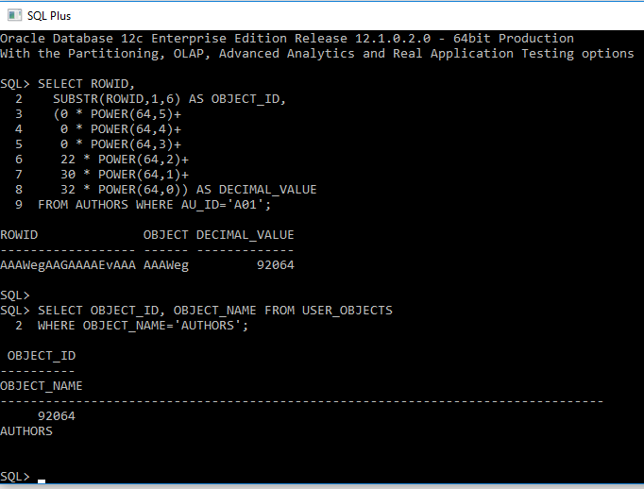

1. [2] List the *title_id, title, units sold, current price* and proposed new 20% higher price of all books. Label the proposed new price column "*Target Price*". Sort the results in descending incremental dollar amount.

SELECT TITLE_ID, TITLE, SALES AS UNITS_SOLD, PRICE, PRICE*1.2 AS TARGET_PRICE FROM TITLES

ORDER BY (PRICE*0.2) DESC;

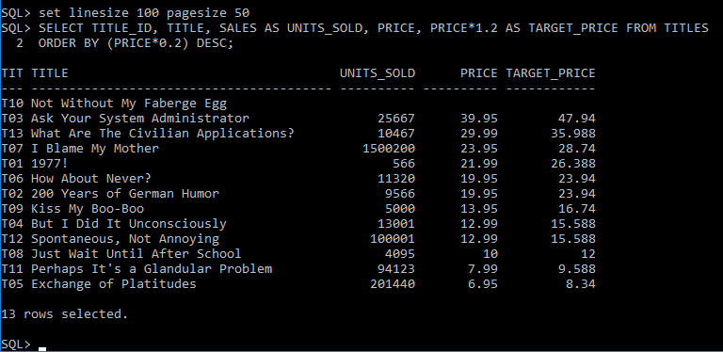

1. [2] List *au_id, fname, lname* and *number_of_books_sold* of the author that has written the most books.

SELECT AU.AU_ID, AU.FNAME, AU.LNAME, AUTIT.TITLE_NUMBERS AS UNITS_SOLD FROM AUTHORS AU

INNER JOIN

(

SELECT DISTINCT AU_ID,

COUNT(TITLE_ID) OVER (PARTITION BY AU_ID) as TITLE_NUMBERS

FROM AUTHOR_TITLES

) AUTIT ON AU.AU_ID = AUTIT.AU_ID

ORDER BY AUTIT.TITLE_NUMBERS DESC

FETCH NEXT 1 ROWS ONLY;

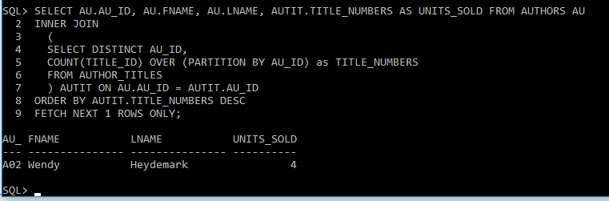

1. [3] List the title_id and title of every book that contains the word '*the*', in any case. For example, “*The house at …”, and “… the road ahead”,* but not *“…another…”.* Sort the results in increasing order according to the location of the *'the'* word. *Hint: Oracle has a function that returns location of a substring within a text string*.

ALTER SESSION SET NLS_COMP=LINGUISTIC;

ALTER SESSION SET NLS_SORT=BINARY_CI;

SELECT TITLE_ID, TITLE FROM TITLES

WHERE TITLE LIKE '% the %'

ORDER BY INSTR(TITLE,'THE',1,1) ASC;

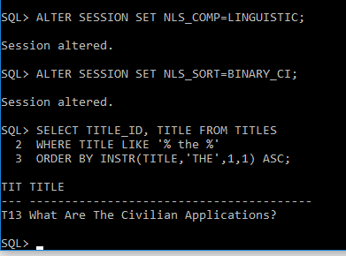

1. [3] List revenue by (*book type* and *publisher*), by (*publisher* and *year*)*,* and overall revenue. Sort by *publisher*.

SELECT T1.GENRE AS BOOK_TYPE, T1.PUB_ID AS PUBLISHER, SUM(T1.REVENUE) AS OVERALL_REVENUE FROM

(

SELECT T.TITLE_ID, T.GENRE, NVL(ROUND(T.SALES*T.PRICE),0) AS REVENUE, NVL(T.PUB_ID, '') AS PUB_ID, T.PUB_GROUP,

ROW_NUMBER() OVER (PARTITION BY T.GENRE ORDER BY NVL(T.PUB_ID, '') ASC) as GENRE_GROUP

FROM

(

SELECT

TITLE_ID, GENRE, PRICE, SALES, NVL(PUB_ID,'') AS PUB_ID,

ROW_NUMBER() OVER (PARTITION BY PUB_ID ORDER BY NVL(PUB_ID,'') ASC) as PUB_GROUP

FROM TITLES

WHERE PUB_ID IS NOT NULL

) T

) T1

GROUP BY (T1.GENRE, T1.PUB_ID)

ORDER BY T1.PUB_ID ASC;

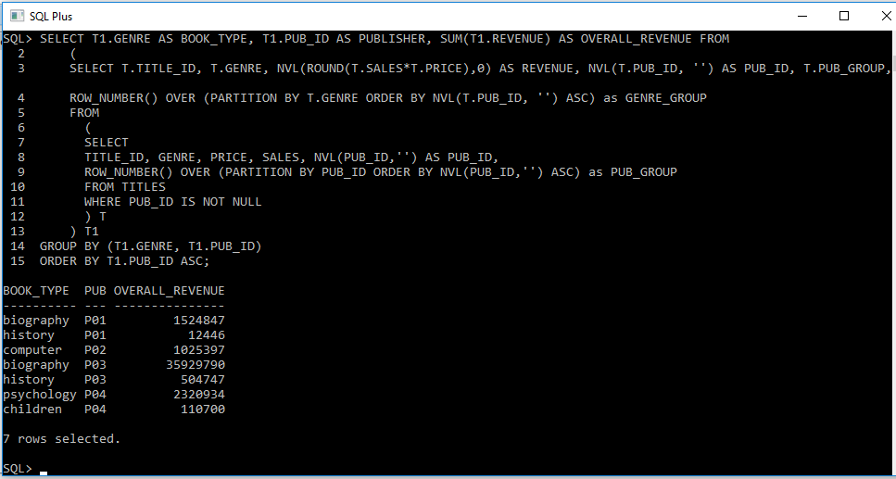

SELECT T1.PUB_ID AS PUBLISHER, T1.PUB_DATE AS "YEAR", SUM(T1.REVENUE) AS OVERALL_REVENUE FROM

(

SELECT T.TITLE_ID, '20'||SUBSTR(T.PUBDATE,8,2) AS PUB_DATE, NVL(ROUND(T.SALES*T.PRICE),0) AS REVENUE, NVL(T.PUB_ID, '') AS PUB_ID, T.PUB_GROUP,

ROW_NUMBER() OVER (PARTITION BY SUBSTR(T.PUBDATE,8,2) ORDER BY NVL(T.PUB_ID, '') ASC) as GENRE_GROUP

FROM

(

SELECT

TITLE_ID, PUBDATE, PRICE, SALES, NVL(PUB_ID,'') AS PUB_ID,

ROW_NUMBER() OVER (PARTITION BY PUB_ID ORDER BY NVL(PUB_ID,'') ASC) as PUB_GROUP

FROM TITLES

WHERE PUB_ID IS NOT NULL

) T

) T1

GROUP BY (T1.PUB_ID, T1.PUB_DATE)

ORDER BY T1.PUB_ID ASC;

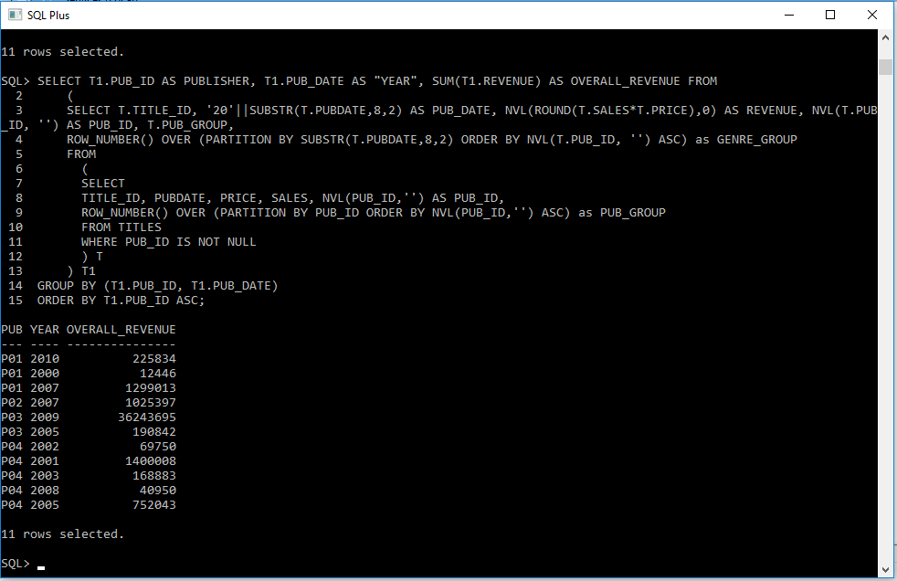

1. [3] List the *title_id, revenue,* and *pub_id* of the book or books that have the greatest revenue for each *pub_id*.

SELECT T.TITLE_ID, T.REVENUE, T.PUB_ID FROM

(SELECT

TITLE_ID, GENRE, PRICE, SALES, NVL(PUB_ID,'') AS PUB_ID, NVL(ROUND(SALES*PRICE),0) AS REVENUE,

ROW_NUMBER() OVER (PARTITION BY PUB_ID ORDER BY NVL(ROUND(SALES*PRICE),0) desc) as PUB_GROUP

FROM TITLES

WHERE PUB_ID IS NOT NULL

) T

WHERE T.PUB_GROUP = 1;

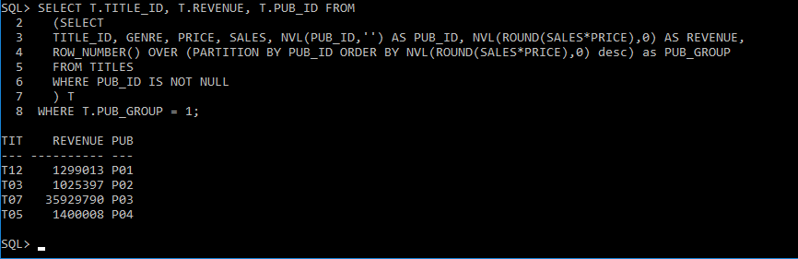

1. [3] Create the following results using a materialized view:

GRANT CREATE MATERIALIZED VIEW TO carlos;

GRANT QUERY REWRITE TO carlos;

GRANT CREATE ANY TABLE TO carlos;

CREATE MATERIALIZED VIEW MV_TITLES AS

SELECT INITCAP(GENRE) GENRE,

AVG(SALES) AS AVERAGE_SALES,

STDDEV(SALES) AS STDDEV_SALES

FROM titles

WHERE GENRE IS NOT NULL

GROUP BY GENRE

ORDER BY AVG(SALES) DESC;

COLUMN AVERAGE_SALES FORMAT 999,999.999

COLUMN STDDEV_SALES FORMAT 999,999.999

SELECT * FROM MV_TITLES;

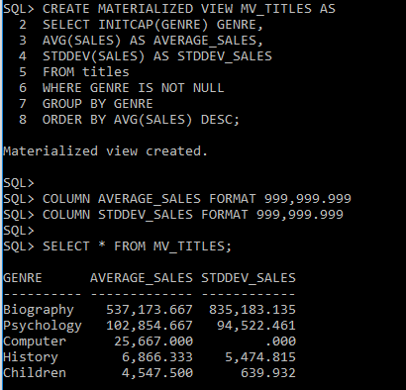

[3] Use the materialized view created above to generate the following results:

SELECT T.TITLE_ID,

INITCAP(T.GENRE) as GENRE,

T.SALES,

MVT.AVERAGE_SALES,

MVT.STDDEV_SALES,

(MVT.AVERAGE_SALES+MVT.STDDEV_SALES) as "Sales Plus StdDev"

FROM TITLES T

INNER JOIN MV_TITLES MVT ON T.GENRE = MVT.GENRE

WHERE T.SALES > MVT.AVERAGE_SALES+MVT.STDDEV_SALES

ORDER BY SALES DESC;

COLUMN SALES HEADING SALES JUSTIFY CENTER FORMAT 999,999,999

COLUMN TITLE_ID HEADING 'Title|Id' JUSTIFY CENTER FORMAT A8

COLUMN Genre HEADING GENRE JUSTIFY CENTER

COLUMN STDDEV_SALES HEADING 'Stddev|Sales' JUSTIFY CENTER FORMAT 999,999.99

COLUMN AVERAGE_SALES HEADING 'Avg|Sales' JUSTIFY CENTER FORMAT 999,999.99

COLUMN 'Sales Plus StdDev' HEADING 'Sales plus|Stddev' JUSTIFY CENTER FORMAT 9,999,999.99

